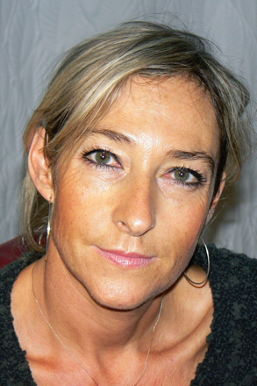

**Emmanuelle GASTALDI**

Université de Montpellier (UM) Associate Professor (MCF)

UMR 1208 IATE – Ingénierie des Agropolymères et Technologies Emergentes Montpellier, France

Emmanuelle Gastaldi is Associate professor at the University of Montpellier and she is conducting research activities in the field of biopolymers and biodegradable polymers at UMR IATE. Trained as a biochemist, Emmanuelle Gastaldi holds a PhD in Food Science.

Her primary domains of expertise are structuring/de-structuring of polymers for designing and functionalizing materials with low environmental impact for target applications in the field of food packaging and agriculture, notably biodegradable mulch films. At this purpose, she has been invited at a Breakfast Workshop at the European Parliament (2017) and has been requested as expert in biodegradability by the French Ministry “Transition écologique et solidaire” (2019).

In the last few years, she has been interested in the plastic waste issues with a special focus on their end of life options and their fate in terrestrial and aquatic environments through her involvement in SerpBio association and the scientific comity of the GDR “Polymères et Océans”.

She has participated in several projects (ADEME, ODEADOM/AFB, ANR, INRA, European).

She published 50 papers in international journals and 6 book chapters.